Membership in a Living History Museum

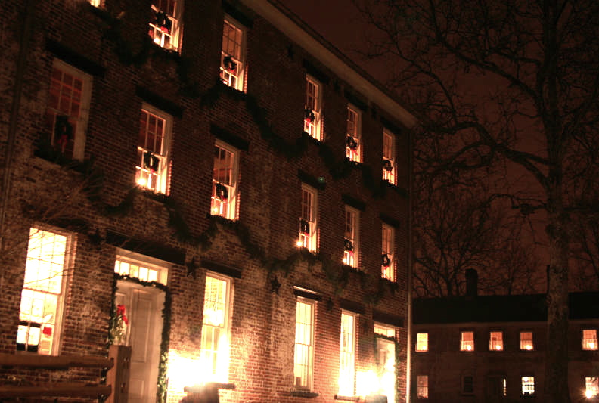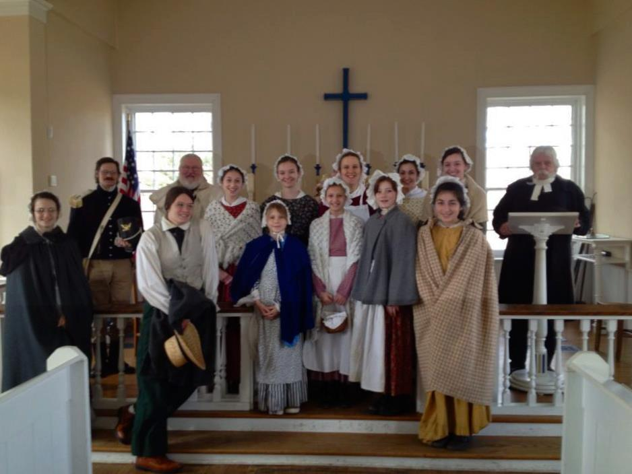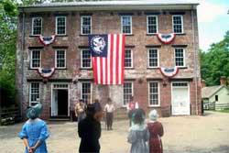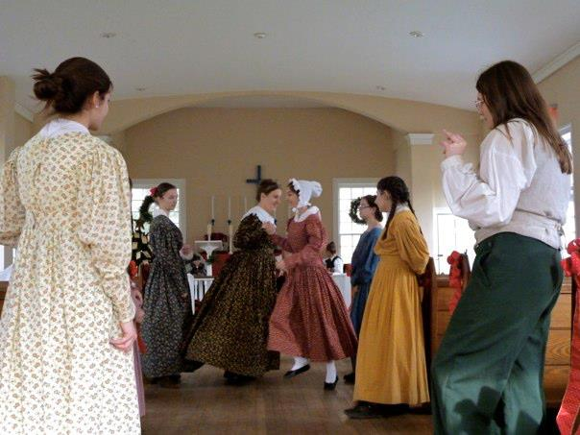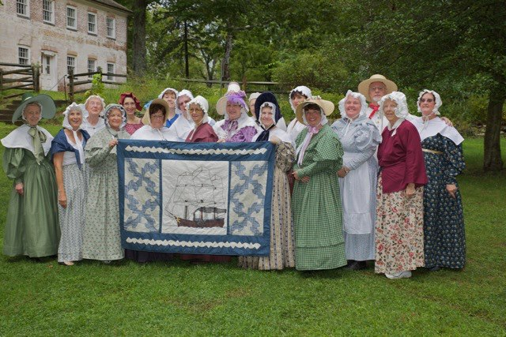

Allaire Village is Alive! The blacksmith is making tools and household wares, while the carpenter is finishing a mold or toy at his bench. The Villagers welcome you to the Manager’s House and give you a tour of Mr. Allaire’s Mansion in the country. Don’t forget that our General Store, Enameling Building, and Bakery offer unique gifts and yummy treats for the whole family!
Whether visiting or volunteering, be a part of living history. Become a member today!

MEMBERSHIP LEVELS

Allaire Volunteer, Senior, Student or Active Military | $20
Individual | $35
Family (up to 5 individuals living in one household) | $50
Contributor | $150
Supporter | $250
Donor | $500
Sustaining Member | $1,000
Chairman’s Circle | $1,500

MEMBERSHIP BENEFITS *
- Allaire Volunteers, Seniors, Students, Active Military receive:
- Participation in a 26-acre, 13 building, living history museum.
- 10% discount at our General Store (excluding food.)
- Free admission to historic buildings (excludes lantern tours)
- Free admission to flea and craft markets.
- Quarterly subscription and recognition of membership in our Village Star newsletter.
- Invitation for one (1) to membership events.
- Discounts on public workshops and lectures (for 1 person).
- Volunteers become eligible for scholarship and award selections.

- Family - All of the items listed above, plus:
- One additional invitation to members’ events (total of 2).
- Discount on public workshops and lectures for (1) additional person (total 2.)
- 10% discount at the Bakery.

- Contributor – All of the items listed above, plus:
- A guided tour for up to five individuals, once a year on a non-event day. (Please call for advanced scheduling.)
- Additional invitation for members’ events (total 3)

- Supporter -All of the items listed above, plus:
- Ability to participate in “A Day in the Life” program. Up to four individuals are able to experience first-hand life as a member of the village. Call for advanced scheduling.
- Supporting members will receive an invitation for one (1) to our luncheon
honoring our volunteers.

- Donor – All of the items listed above, plus:
- Two (2) Tickets to our Fall Harvest Festival (includes wagon rides)
(Please call for scheduled date and to reserve your tickets)
- Invitation for two (2) to our luncheon honoring our volunteers.

- Sustaining Member – All of the items listed above, plus:
- Four (4) tickets to “Christmas at Allaire”, our #1 event of the winter – start a
holiday tradition for yourself and your family!

- Chairman’s Circle - All of the items listed above, plus:
o Four (4) free tickets to a Holiday Lantern Tour. (Please call to reserve your tickets in
advance.)

*Membership card must be presented to receive benefit.

Looking for a gift for that person who has everything? Gift a membership to The Historic Village at Allaire to those grandparents or loved ones who already “have it all!”

ANNUAL MEMBERSHIP FORM
CIRCLE ONE: NEW RENEWAL GIFT
Name:
Address:
City: State: Zip
Email: Phone:
Membership paid by check should be made payable to: Allaire Village Inc.
To pay by credit card, please contact The Historic Village at Allaire at (732) 919-3500 or email: info@allairevillage.org
Mail Membership Application and check to:
Allaire Village Inc.
4263 Atlantic Avenue, Farmingdale, NJ 07727
Attn: Membership Chair
Thank you for supporting The Historic Village at Allaire!

